Contents

Manual Testing 1

Objectives: 1

Scope 1

Resources 1

Schedule 1

Deliverables 1

Test Items 2

Test Cases 2

Test Execution 4

Test Reports 4

Bibliography 5

# Manual Testing

The purpose of testing is to unearth bugs, defects in a software product. The software is tested to confirm that it works as intended. The various set of patterns for designing and choosing tests to perform (Bach, 2024).

## Objectives:

To test the Wikipedia URL. To identify all defects while using the Wikipedia website.

## Scope

Wikipedia exists in many languages. The English language Wikipedia will be tested only. The following functionalities will be tested.

* Navigation
* Searching
* Content Display
* User accessibility

The following will not be tested.

* Editing webpages
* Created accounts including registering editor accounts

## Resources

* Windows machine
* Chrome browser
* Human resource, Navdeep will be performing the manual tests.

## Schedule

The test will be perform on August 2024. The tests will be perform in a weeks’ time. The report will be available after the execution of the tests.

## Deliverables

A report recording all defects found and their severity. The end results will be shared. The purpose of deliverables to full understand manual testing. They are not part of any Wikipedia project.

## Test Items

The following items will be tested.

* Search functionality including, Autosuggestion of topics
* Display with and without JavaScript enabled
* Navigation between pages

# Test Cases

Test cases are well defined format for software testing (Geeeks, n.d.). It consists of a set of conditions to be checked.

|  |  |
| --- | --- |
| Module Name | Search |
| Test Case ID | Search_01 |
| Tester Name | Navdeep |
| Test Case Description | To test the search functionality of <https://wikipedia.org> |
| Prerequisites | 1. Internet Connection 2. Firefox Browser |
| Environmental Information | 1. OS : Windows 10 2. System : Laptop |

|  |  |  |  |  |  |  |  |  |  |  |
| --- | --- | --- | --- | --- | --- | --- | --- | --- | --- | --- |
| Test scenario | | | | | | | To check search term functionality of Wikipedia website. To check topic suggestions | | | |
|  | | | | | | | | | | |
| Test Case ID | | **Test Steps** | | | **Test input** | | **Expected Results** | | **Actual Results** | **Status** |
| 1 | | Visit <https://wikipedia.org> | | | Olympics | | A suggestion of relevant topics | | Olympic Games | **Pass** |
| Enter search term | | | Olympic Symbols |
| Wait a few seconds | | | Olympics on CBC Commentators |
| Test scenario | | | | | | | To check search term functionality of Wikipedia website.  To check topic suggestions of non-existing topic | | | |
|  | | | | | | | | | | |
| Test Case ID | | | **Test Steps** | | **Test input** | | **Expected Results** | | **Actual Results** | **Status** |
| 2 | | | Visit <https://wikipedia.org> | | hjfgdk | | No suggestion is shown | | Nothing is shown. No suggestion popup | **Pass** |
| Enter search term | |
| Wait a few seconds | |
| Test scenario | | | | | | To check search term functionality of Wikipedia website. To check detailed response of a search term. | | | | | |
|  | | | | | | | | | | | |
| Test Case ID | **Test Steps** | | | **Test input** | | **Expected Results** | | **Actual Results** | | **Status** | |
| 3 | Visit <https://wikipedia.org> | | | Olympics | | A detailed results page which include the word ‘Olympics’ | | The page  <https://en.wikipedia.org/wiki/Olympic_Games> is shown. | | **Pass** | |
| Enter search term | | |
| Click the search button which look like hourglass | | |

|  |  |
| --- | --- |
| Module Name |  |
| Test Case ID | Accessibility_01 |
| Tester Name | Navdeep |
| Test Case Description | To test the search functionality of Wikipedia without Javascript |
| Prerequisites | 1. Internet Connection 2. Firefox Browser 3. UBlock Origin |
| Environmental Information | 1. OS : Windows 10 2. System : Laptop |

|  |  |  |  |  |  |
| --- | --- | --- | --- | --- | --- |
| Test scenario | | | To check search term functionality of Wikipedia website. To check topic suggestions | | |
|  | | | | | |
| Test Case ID | **Test Steps** | **Test input** | **Expected Results** | **Actual Results** | **Status** |
| 4 | Visit <https://wikipedia.org> | Olympics | A result pages which is readable. | Olympic Games | **Pass** |
| Disable JavaScript using UBlock Origin extension | Olympic Symbols |
| Enter the search term | Olympics on CBC Commentators |
| Click the search icon |

# Test Execution

The tests was by Navdeep using Windows Laptop. Firefox browser was used to visit Wikipedia website. The following extension was used [UBlock Origin Website](https://ublockorigin.com/).

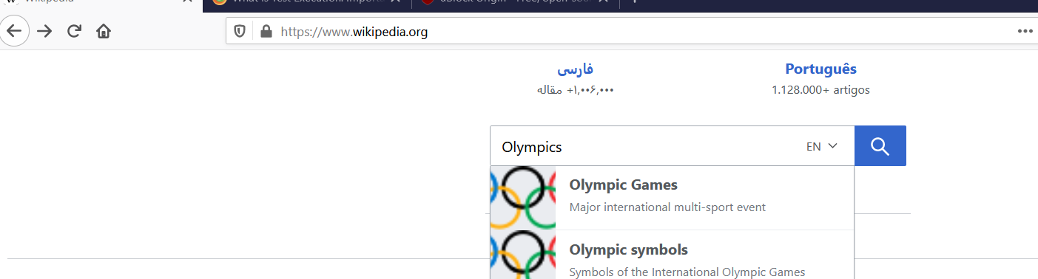

# Test Reports

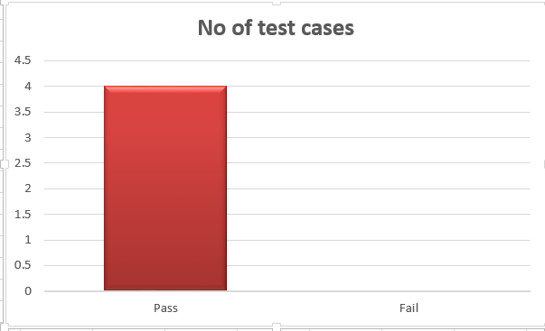

# Bibliography

Bach, J. (2024). *Heuristic Test Strategy Model.* www.satisfice.com.

Geeeks, G. f. (n.d.). *How to write Test Cases – Software Testing*. Retrieved from https://www.geeksforgeeks.org/test-case/